How to Place an Advert on the PA Noticeboard
Go to https://portsmouth.panoticeboard.org.uk and click 'register' at the top right of the 'Home' page:
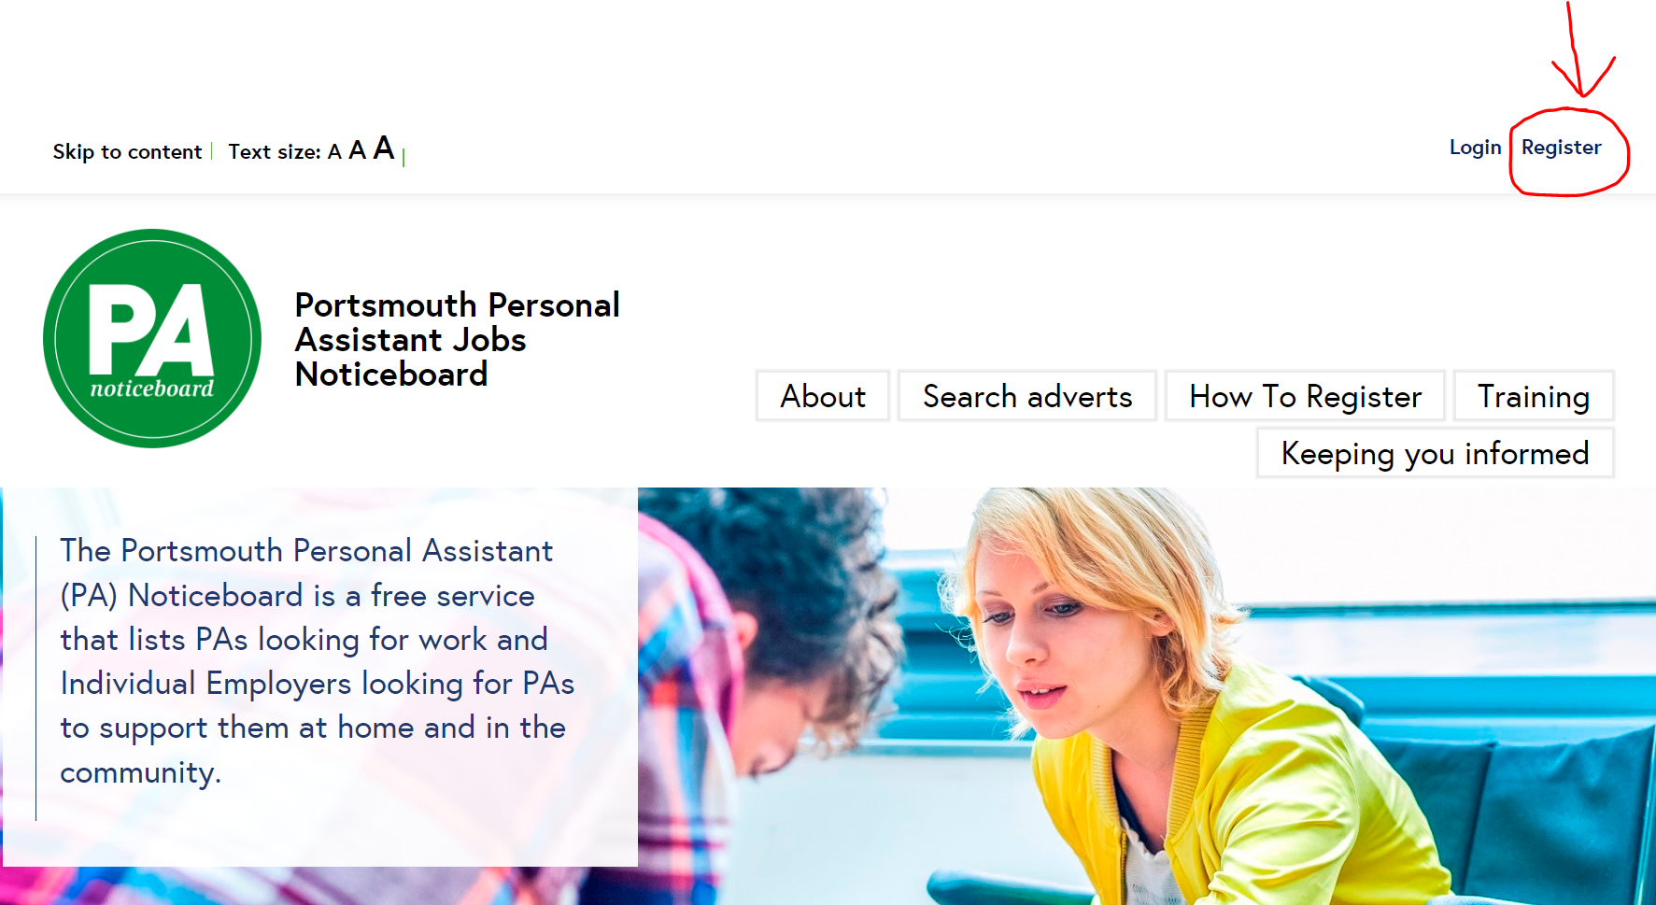

You will need to create an account as a ‘direct employer looking for a PA’ (anyone can place an advert on behalf of the individual that needs support):
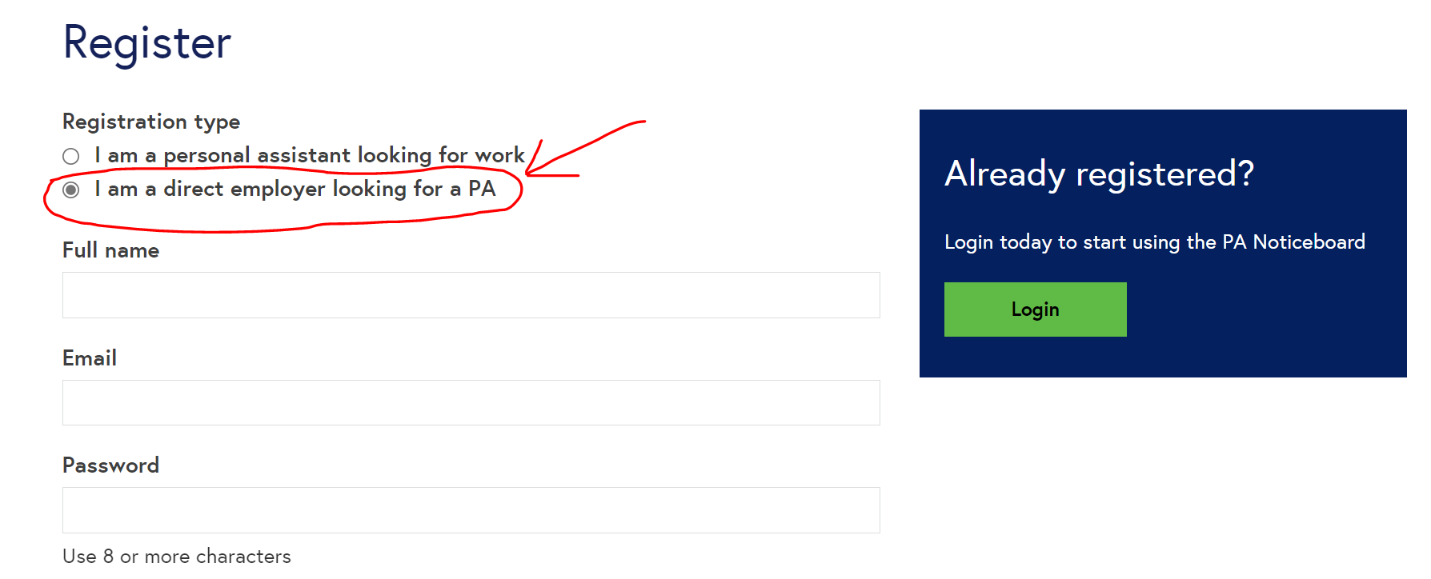
- Enter your name in the ‘Full name box’, enter your email address in the ‘Email’ box (this is the email address you will receive any notifications relating to your advert to)
- Create a password in the ‘Password’ box, choose something you’ll easily remember as you’ll need to log in again.
- You’ll also need to select how you heard about the PA Noticeboard from the drop down list before it will let you register.
- Click ‘Register’
• Once you’ve registered an activation link will be sent to the email address you registered with (remember to check your junk email folder if it doesn't arrive). Click on the link to activate your account. You’ll only need to do this once.
• Once you have clicked on the link to activate your account, you will be directed to this page where you can complete the details for your advert:
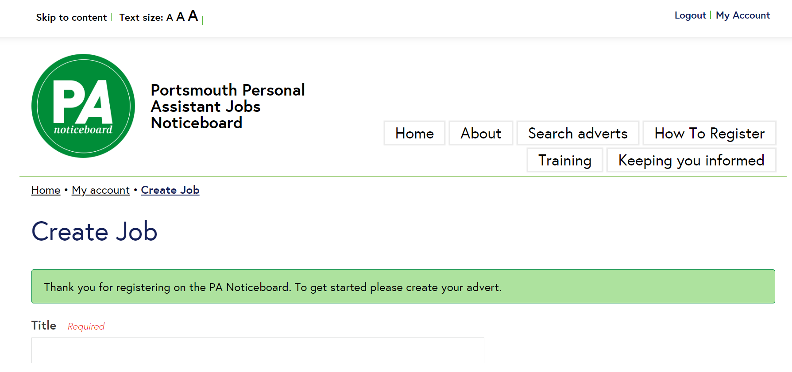
Title
In the title box include a brief description to attract the immediate attention of the PA. e.g. “4 hours per week community support for young man in Southsea”
Summary
This is the main portion of your advert and should contain information that best represents your needs and should be kept generic and not include any personal information such as name, address etc. It’s helpful to include activities/hobbies and interests here to find the best suited PA.
This section should also include a breakdown of the working hours/days and the requirements of the role, for example: personal care, accessing the community, meal preparation or overseeing medication. Include here any additional information such as medical conditions, if there are animals at your home etc.
Which genders may apply for this job?
If the role involves personal care, then specify whether you would prefer a male or female PA. Otherwise you can choose ‘not relevant for this role’.
How many hours is the PA required to Work?
Specify how many hours and on what days e.g., 1 hour AM Monday – Friday (5 hours in total).
Hourly rate
Specify the rate you will be paying your PA.
If you are employing a PA, this must be above the National Minimum Wage
Direct Payment clients must check the funded rate with their Practitioner.
Area
Tick the box next to the area where you live.
Do you require your PA to have a valid driving licence?
Select Yes or NO, remember that if you require access to the community for shopping or appointments etc. this will be required.
Do you have pets?
Select Yes or No
Are you a smoker?
Yes or No
What previous care experience is required?
Decide what you would like your PA to have experience in and tick as appropriate.
Declarations
You will need to read through the declarations then show your agreement by ticking the boxes next to each declaration.
Save Entry
Click 'save entry' to create the advert:
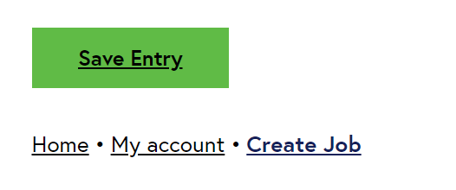
Once you click ‘Save Entry’ the PA Noticeboard will receive your advert and moderate it before publishing.
Once published, you will be able to see your advert on the PA Noticeboard.
If you have any PA applicants, you will receive a notification via the email you used to sign up for your account.
You can view the applications by logging in to your account on the PA Noticeboard and click on ‘My Account’ at the top of the screen.

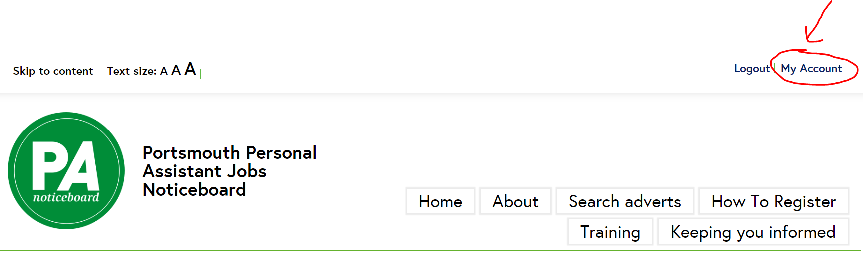
Click ‘Applications’, this will open a list of all the applications you have received:

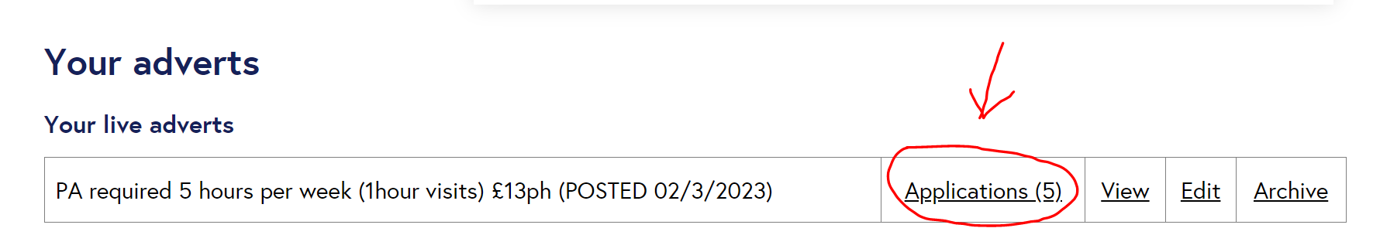
Click in view application and this will open the cover letter for the application:
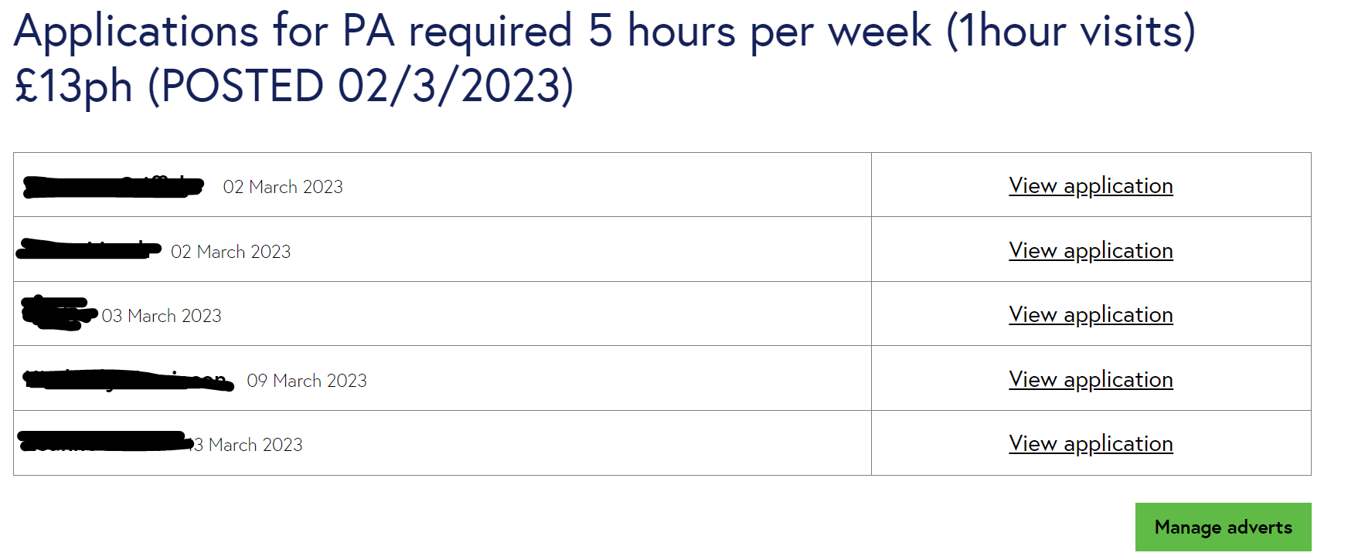
If the PA has left their contact details in their cover letter, contact them using this method of contact. If they have not left any contact details, you can contact them using the reply to applicant function on the noticeboard.

